**Simple pendulum**

**Aim**

Determination of the acceleration due to gravity

**Definitions**

**Periodic motion:** is the motion that repeats itself in regular time

**Simple harmonic motion:** Motion of vibrating particle in which the restoring force is proportional to its displacement but in opposite direction

**Periodic time:** time of one vibration T (sec)

**Frequency:** number of vibration per second f (Hz)

**Amplitude:** the maximum displacement of vibrating particle

**Law**

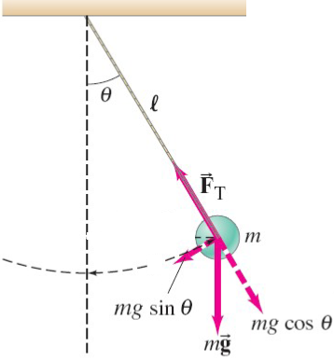

Where

T periodic time of motion

g acceleration due to gravity

L length of pendulum

**Equipment:**

Simple pendulum ruler meter

Stop watch

**Method:**

1- Adjust the length of pendulum L = 30 cm

2- Allow the pendulum to vibrate at small angle

3- Find the time of 20 complete vibrations T20

4- Calculate the periodic time T = T20 / 20

3- Repeat above steps for different lengths (40, 50 …. cm)

4- Plot the relation between T2 & L, which give straight line

5- Calculate the acceleration due to gravity g = 4 π2 / slope

**Table**

|  |  |  |  |
| --- | --- | --- | --- |
| L  (cm) | T20  (sec) | T =  T20 /20  (sec) | T2  (sec2) |
| 30  40  50  60  70  80 |  |  |  |

G**raph**

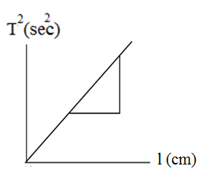

**Results**

Slope =

Acceleration g = 4 π2 / slope = ---- (cm/sec2)